# 

UNIVERSITY OF SCIENCE AND TECHNOLOGY OF HANOI

**UNDERGRADUATE SCHOOL**



**BACHELOR THESIS**

By

**DANG THAI SON (BA9-053)**

*Information and Communication Technology (ICT)*

Title

**Research Magento E-commerce platform: Create a Fast Order Module**

------------------------------------------------------------------------------------------------------------------

External supervisor: **Mr. Nguyen Van Thanh**

*ArrowHiTech Joint Stock Company*

Internal supervisor: **Dr. Nghiem Thi Phuong**

*ICT Laboratory - USTH*

**Hanoi, June 2022**

# TABLE OF CONTENTS

TABLE OF CONTENTS 2

ACKNOWLEDGEMENTS 4

LIST OF ABBREVIATIONS 5

LIST OF FIGURES 6

ABSTRACT 7

INTRODUCTION 8

I/ Context and Motivation 8

1. Context 8

2. Motivation 8

II/ Internship timeline 9

III/ Company and its sector of activities 10

OBJECTIVES 11

MATERIALS AND METHODS 12

I/ Application analysis 12

1. User requirements 12

2. UML diagrams 12

a) Use-case diagram 12

b) Sequence diagrams 13

II/ Technologies and tools 16

1. HTML, CSS and LESS 16

2. JavaScript, jQuery, Knockout.js, and AJAX 17

3. Magento platform 17

a) PHP and Zend framework 18

b) MySQL database 18

III/ Design and methods 18

1. Project explanation 18

a) Magento theme customization 19

b) Fast Order extension 21

2. Architecture 23

a) System architecture 23

b) Module architecture 26

3. Implementation 26

RESULT AND DISCUSSIONS 30

1. Result 30

2. Discussion 31

CONCLUSION 32

REFERENCES 33

APPENDICES 34

# ACKNOWLEDGEMENTS

I would like to express my gratitude to all those who gave me the possibility to complete this thesis in specific as well as supporting in general that I received during the time of my studying at University of Science and Technology of Hanoi.

First and foremost, I cannot begin to express my thanks to Mr. Nguyen Van Thanh, my supervisor in ArrowHiTech Company, who played a decisive role in helping me finish both my internship and my project. Mr. Thanh had always provided me with encouragement and patience, which shall carry me a long way in the future. In addition, I very much appreciate many other staff in the company, especially in the Training Center, for their unwavering guidance and relentless support during my internship time. They all had given me generous assistance and encouragement when I was working on this project. The internship opportunity at ArrowHiTech Company has strengthened not only my knowledge but also my professional development.

Moreover, I would like to extend my sincere thanks to all staff and lecturers in the Information and Communication Technology Department at University of Science and Technology of Hanoi, particularly Dr. Nghiem Thi Phuong, for valuable information and cooperation throughout the internship. The completion of my dissertation would not have been possible without their nurturing.

Last but not least, I gratefully acknowledge the effort of my classmates who attended my same internship group. Whenever I had difficulty during the time, they are the ones who constantly offered me useful advice and inspiration to get over.

# LIST OF ABBREVIATIONS

AHT TECH JSC ArrowHiTech Joint Stock Company

AJAX Asynchronous JavaScript and XML

CMS Content Management System

CRUD Create Read Update Delete

CSS Cascading Style Sheets

EAV Entity-Attribute-Value

E-commerce Electric commerce

HTML/DOM Hypertext Markup Language/ Document Object Model

JS JavaScript

LESS Learner Style Sheets

MVC Model-View-Controller

MVVM Model-View-ViewModel

OOP Object Oriented Programming

ORM Object Relational Mapping

PHP Hypertext Preprocessor

PSR PHP standards recommendations

SKU Stock-Keeping Unit

SQL Structured Query Language

UI User Interface

URL Uniform Resource Locator

USTH University of Science and Technology of Hanoi

XML eXtensible Markup Language

# LIST OF FIGURES

Figure 1: Timeline 9

Figure 2: AHT logo 10

Figure 3: Use case diagram 12

Figure 4: Login sequence diagram 13

Figure 5: Search sequence diagram 14

Figure 6: Manage-product-list sequence diagram 15

Figure 7:Do-the-checkout sequence diagram 16

Figure 8: Magento container 19

Figure 9: Magento block 20

Figure 10: EAV model 21

Figure 11: Magento product EAV 22

Figure 12: Magento system architecture 23

Figure 13: ORM programming technique 25

Figure 14: MVVM design pattern 26

Figure 15: "search" action's URL 27

Figure 16: Search keyword’s data sent 27

Figure 17: Product’s data received 28

Figure 18: "add" action's URL 29

Figure 19: Product list's data sent 29

Figure 20: Magento theme customization 30

Figure 21: Fast Order module 31

# ABSTRACT

My three-month internship at ArrowHiTech Joint Stock Company focused on working with Magento E-commerce platform, a powerful PHP framework used to make online stores. My main jobs are studying the software’s basic characteristics and functions, customizing a theme for practice, and creating a module to improve the order process which is initially slow and inconvenient. Among these, creating module “Fast Order” is the target of the project. The extension is built mostly by Knockout.js with AJAX. In this paper, I will point out several reasons for the drawbacks of the default order process, hence the need for this new module. Then I will go through the workflow of the extension, some technologies used, and its architecture. Subsequently, my proposed implementation for the project will be put forward. In the end, I will hold some discussion in terms of the result, the difficulties, and ideas for future improvement of the system.

**Keywords**: *PHP, Magento, E-commerce, Module, Order process, Knockout.js*.

# INTRODUCTION

## I/ Context and Motivation

### 1. Context

In today’s modern world, when the Internet is becoming an indispensable part in people’s lives, everything is trending towards digitizing namely the education (classes are being taught online, students can do examinations at home using the Internet…), the entertainment industry (the bloom of movie streaming services, virtual concerts...), and the commerce... Indeed, E-commerce has become a requisite for all business categories thanks to its 24/7 availability, easy accessibility, international reach, lower product costs… In the past few years when the COVID-19 pandemic broke out, this platform has been even more popular. With customers having a lot more spare time and potential shoppers confined to their home without any convenient way to do the shopping, E-commerce rocketed drastically. As a result, the demand for modern websites and special functions to serve customers effectively increased too. During my three-month internship in AHT, I had been guided to make a quite interesting and useful module for a commercial website called the Fast Order.

To begin with, the Fast Order module was a small task in an E-commerce project of AHT, which was then made simple for internship students like me to practice by omitting some complicated features. This project is expected to be an individual work written in PHP. I built this module using the Magento platform which is one of the most famous E-commerce platforms in the world and also a main sector of activity of AHT due to its many ready-built features, flexibility, and good back-end organization…

### 2. Motivation

In terms of the function, as the name stated, it is used to order rapidly. Normally, if customers want to purchase something at a Magento online store, they have to either go to the product list page or access the detail page of that product and then add it to the shopping cart, which would cause inconvenience to ones who need to buy several items at once. Furthermore, the default Magento cart is very slow in terms of updating the products. For example, there are already several items in a customer’s cart but he changes his mind and wants to either alter the quantity or remove some of them from the cart. All those actions need communication between the cart interface and the controller, which would cause lots of unpleasant waiting time.

This Fast Order module optimizes the ordering process firstly by enhancing the search speed. Applying AJAX, users can immediately see the results whenever they enter a keyword. Secondly, it allows adding multiple products to the cart quickly. More specifically, with this function shoppers can select numerous items at the same time directly on the search bar to make a list, alter their quantities while avoiding to inform the controller, and check the total price before adding that whole list to the cart to make orders without having to visit any other product pages.

## II/ Internship timeline

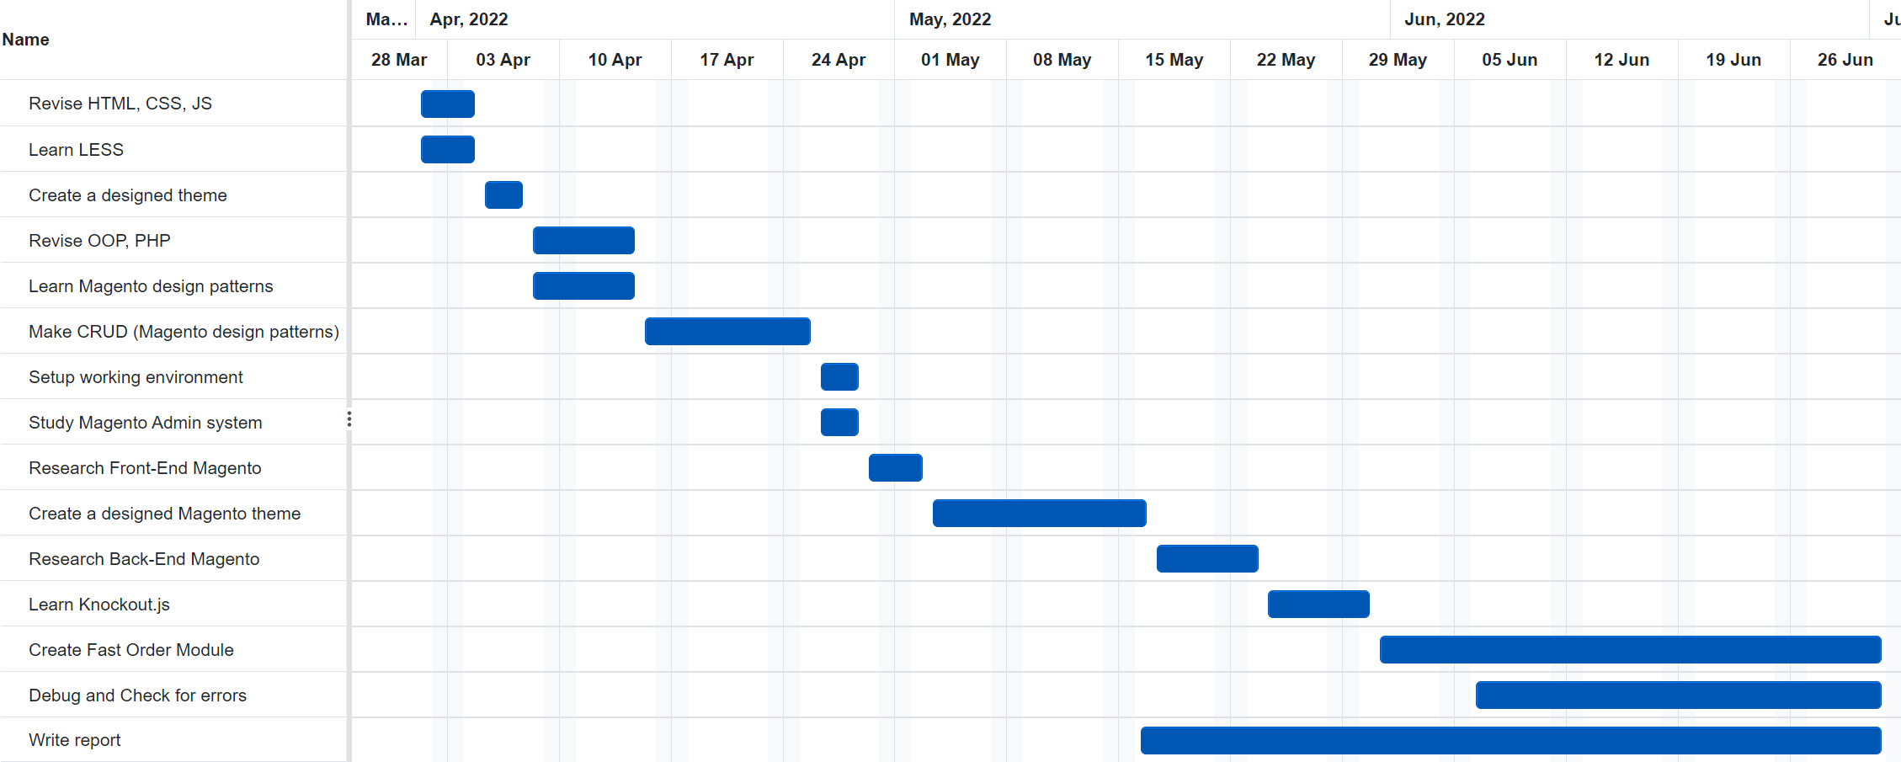

Figure 1: Timeline

Choosing Magento, a complex framework, to work with was a real challenge for me because there was a huge amount of work needed to be done to get familiar with it. My internship started on the first of April. Since training in a company, I had to spend a few days learning its general process, coding standards… Simultaneously, I revised the basic knowledge of web programming like HTML, CSS, JS, which did not take much time thanks to Web Application Programming course at USTH, and studied LESS, a CSS preprocessor used in Magento theme. Then I was required to make a layout utilizing those technologies. In the following two weeks I went over OOP and PHP, learned some Magento design patterns and practiced by creating CRUD operations. Only after that was I able to work with Magento. Firstly, it took me nearly a week to set up the working environment, study most basic functions of the Magento Admin system, and research the fundamental structure of its Front-End. Later, I had to customize a Magento theme to get used to the platform. When I had enough knowledge about the framework, I started to work on the Back-End part by exploring its work flow, some critical components, and Knockout.js which is used a lot in Magento modules generally and my Fast Order module specifically. From the end of May onwards, I tried to implement the project code, debug and check for as many errors as possible.

In respect of the report, I began to form structure and make ideas from the middle of May.

## III/ Company and its sector of activities

Established in 2007, AHT TECH JSC offers technology-driven solutions of various scales such as E-commerce solutions, Digital Transformation solutions, Web/Mobile Apps Development, Software Consulting and Development, Graphic and Creative Design. With over three hundred members, AHT has three local branches in Hanoi, Thai Nguyen, Phu Tho; four international offices and three subsidiaries: AHT Japan, AHT Solutions, AHT Training Center. The company mainly focuses on popular technologies including Odoo, Magento, Shopify, WooCommerce, Flutter combining with Artificial Intelligence, Blockchain, Web 3...

*Company logo:*



Figure 2: AHT logo

*Telephone number: (+84)24 3795 5813*

*E-mail address: info@arrowhitech.com*

*Web link:* [*https://www.arrowhitech.com/*](https://www.arrowhitech.com/)

# OBJECTIVES

In this internship, my purpose is to apply the knowledge in web application programming at school to a real project, then I may be able to acquire and improve new techniques in web-related programming languages. Moreover, since working in a professional environment, I would like to enhance more soft skills such as teamwork, problem-solving and communication skills. I also want to understand the flow of a project in a company and the real working conditions of this occupation to support my future career development.

With regard to this project specifically, I aim to study the Magento framework, both Front-End and Back-End parts, from the practical experience of seniors in the company to be able to manage Magento’s basic functions. Besides, I want to apply my knowledge about Magento in customizing an E-commerce theme and implementing the Fast Order module that runs smoothly. In detail, the module should be able to search and make an order list from the store quickly, containing additional features like altering the amount and checking the total price prior to adding them to cart.

# MATERIALS AND METHODS

## I/ Application analysis

### 1. User requirements

The Fast Order module mainly focuses on the buyers of the online store, so there are only requirements of one user type: **ONLINE CUSTOMER**

* Login to the store: customers must login to access the module
* Search for products
* Choose products to buy
* Alter the amounts of chosen products in the list
* Check the detail price
* Add the chosen list to cart all at once
* Do the checkout: after choosing products, users can proceed to the checkout

### 2. UML diagrams

#### a) Use-case diagram

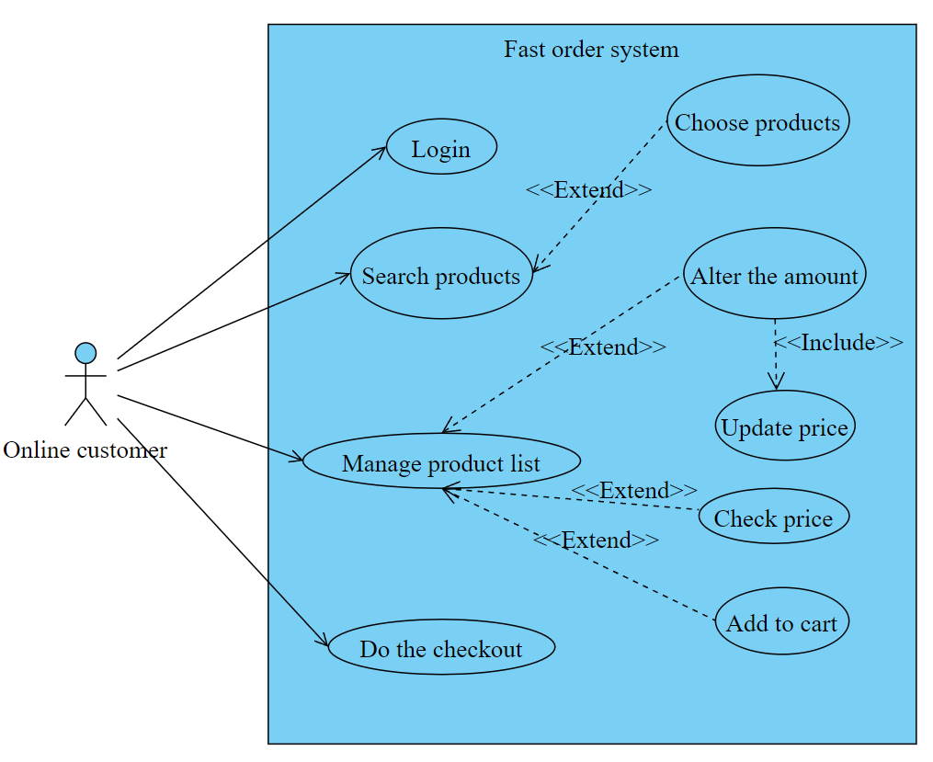

Figure 3: Use case diagram

In line with initial user requirements, this is the proposed use-case diagram where the whole project is based.

#### b) Sequence diagrams

According to the use cases, there are four main sequence diagrams: Login sequence, Search sequence (including choosing products), Manage-product-list sequence (including altering the amount, checking the detail price, and adding to cart), and Do-the-checkout sequence. Thanks to the Magento platform which is formed based on the module structure and has high priority for reuse, two use cases login and checkout are already well implemented, so their sequences are just the demonstration for the system workflow. This project concentrates mainly on the other two sequences.

**LOGIN SEQUENCE DIAGRAM**

This diagram shows the system’s login process. After entering email and password, a customer must click the “Login” button. The information is sent to the controller and validated based on the user’s account database. If the account is true, the customer can login to the store, else, the system will inform the user to re-enter email or password.

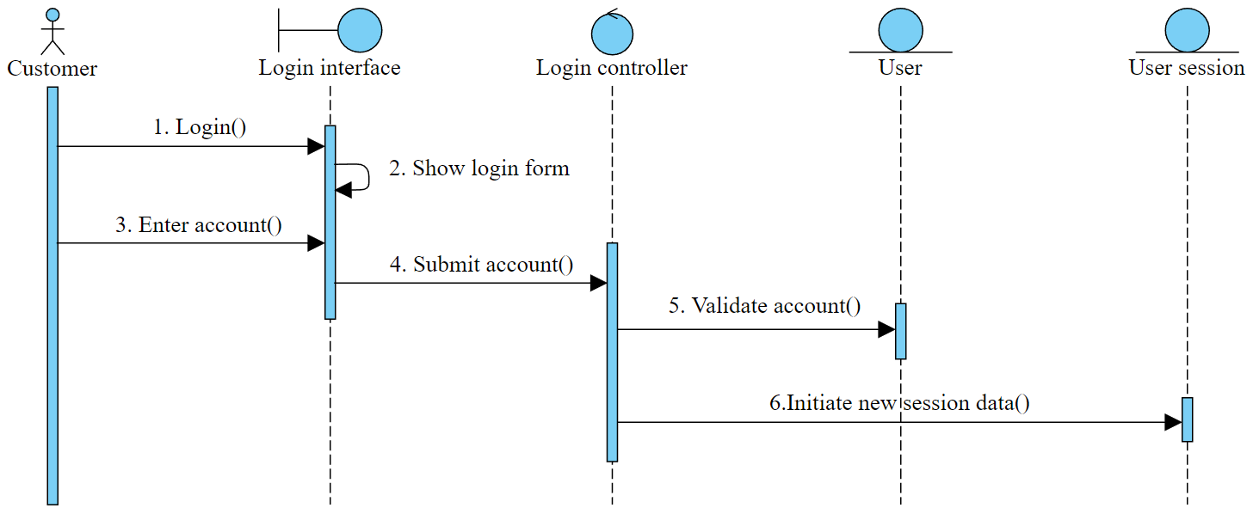

Figure 4: Login sequence diagram

**SEARCH SEQUENCE DIAGRAM**

In the search function, there are four main objects consisting of a customer, an interface, a controller, and a product database. To begin, a customer has to submit search keywords via the interface to the controller. Then the controller searches for a product in the database with a name or SKU code similar to the query. If there is any available product, the result will be displayed on the interface so that the user can choose them to make a list and add to cart later. Otherwise, if there is no result matching the description, the interface will show nothing.

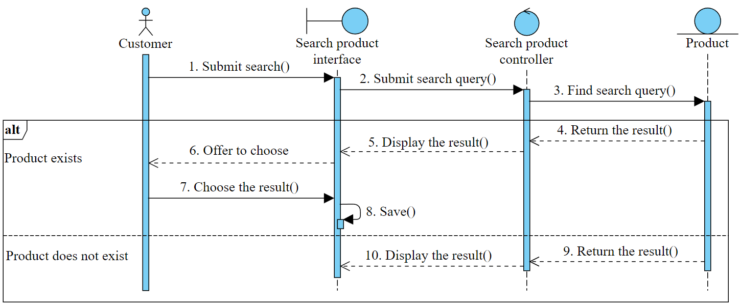

Figure 5: Search sequence diagram

**MANAGE-PRODUCT-LIST SEQUENCE DIAGRAM**

In the managing product list function, there are also four main objects consisting of a customer, an interface, a controller, and a cart database. After having a list of products chosen from the search function above, the customer can change the quantity and keep track of the total price. Next, he has to submit the list. The interface then extracts products’ IDs and quantities for the controller. Subsequently, the controller gets corresponding products based on those IDs and adds them to the cart’s database. The cart saves the products and returns the result to the controller. If the adding succeeds, the controller will inform the interface and clear the old list; else it will display an error message on the interface.

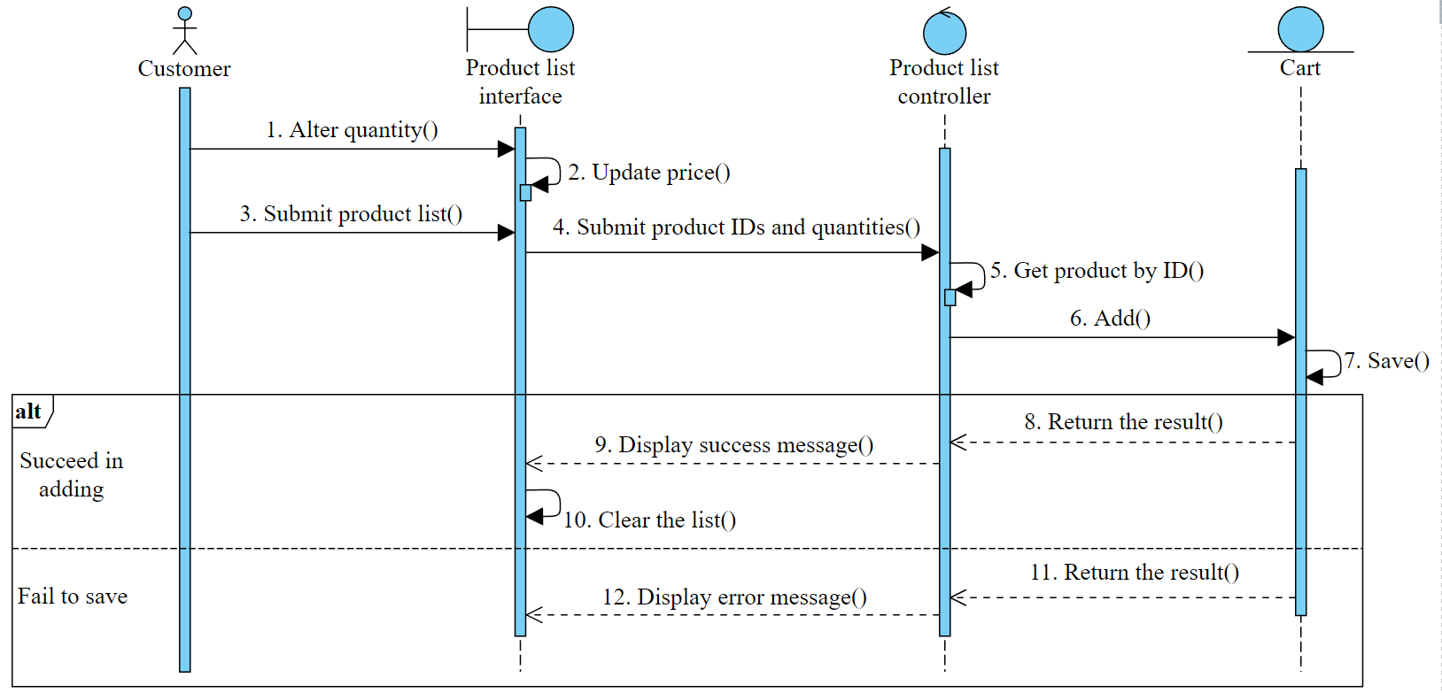

Figure 6: Manage-product-list sequence diagram

**DO-THE-CHECKOUT SEQUENCE DIAGRAM**

When having products in the cart, a customer can proceed to the checkout page , enter required information and click a button to place an order. Data about products’ IDs, quantities… is sent to the controller to get the correct items from the product database. Subsequently, that data is added and saved to the order database. When everything is done, a message is sent to the interface to inform the customer.

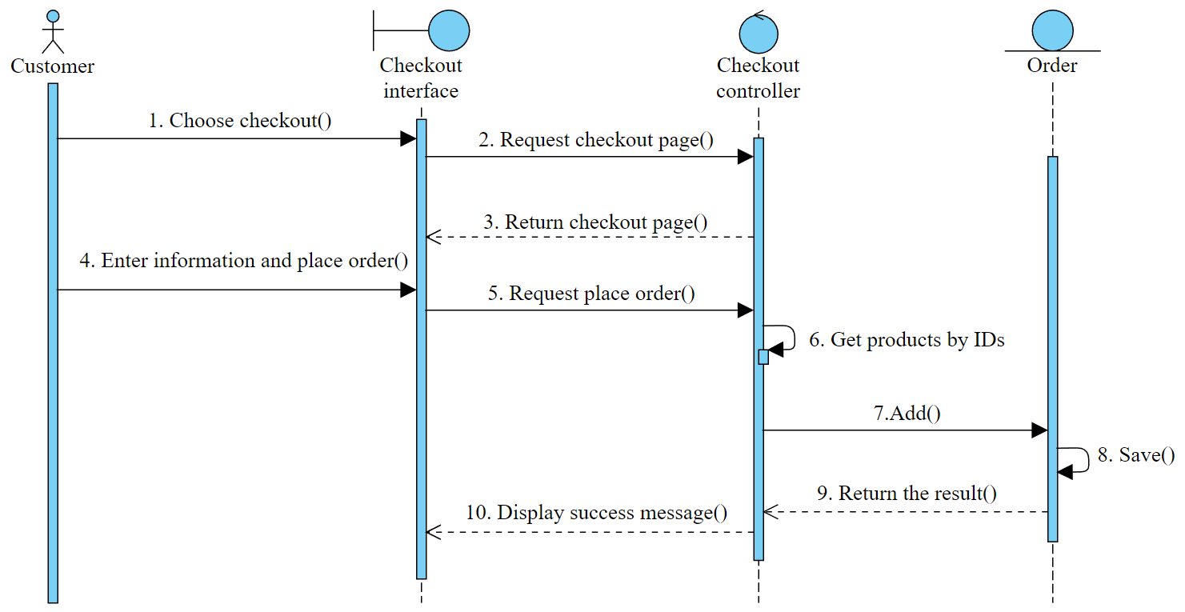

Figure 7:Do-the-checkout sequence diagram

## II/ Technologies and tools

### 1. HTML, CSS and LESS

HTML stands for Hypertext Markup Language. It consists of elements showing the structure of a Web page, controlling the appearance of web documents. HTML is the standard markup language for creating Web pages and Web applications.

CSS is short for Cascading Style Sheets. CSS defines the layout of web pages by describing how HTML elements are to be displayed on screen. Thanks to this language, web pages can become much more elegant, cutting-edge and well-designed. These two technologies combine to make the most critical and fundamental part of websites today.

LESS, or Learner Style Sheets, is a backwards-compatible language extension for CSS. It is a preprocessor which makes some additions to CSS such as variables, mixins, functions, and operations to make styling websites effective, convenient and flexible. The reason for choosing the technique is that for large projects like this, clean and short CSS is required to save time and effort. If developers only use CSS, it will be exhausting to style pages line by line. Fortunately, like a framework, LESS provides the possibility to make variables and mixins (same as classes) which are declared once and can be called anywhere; operations and functions working with numbers, colors, or variables.

### 2. JavaScript, jQuery, Knockout.js, and AJAX

JavaScript is a scripting language which is used to make a website more dynamic by actively updating content, animating images, controlling multimedia… jQuery is a lightweight JavaScript library that provides several features namely HTML/DOM manipulation, HTML event methods, effects and animations, AJAX… to simplify complicated things from JavaScript.

Knockout.js is another JavaScript library that focuses mainly on designing scalable and data-driven UI, binding raw data to a model and updating elements bound to it while jQuery is used for animation and event handling. Knockout.js is used because its MVVM design pattern (Model-View-ViewModel) can be easily applied to the system architecture to make AJAX requests.

AJAX is Asynchronous JavaScript and XML (eXtensible Markup Language, another markup language for storing and transporting data) which helps web pages update fast without reloading when transmitting data between server and client side.

Together, Knockout.js and AJAX are extremely helpful for this project because the main functions always require data exchange between the view and the underlying model with rapid speed.

### 3. Magento platform

Magento is an E-commerce Content Management System (CMS) which gives the online merchants the ability to control the look, the content, and the functionality of their E-commerce sites. It is designed to create powerful online stores and often used by medium-to-large ones. Magento is an open-source software that utilizes PHP programming language, MySQL database, elements of the Zend framework and the Model-View-Controller (MVC) architecture.

Magento stands out among other E-commerce platforms such as OsCommerce, OpenCart, WordPress... due to its power and diversity. Magento has many ready-built features, especially for the admin system, which helps merchants save time and developers save effort. With the most critical functions that an online store should have, there is no need to build everything from scratch except some customizations and advanced modules if necessary. To be more specific, Magento Admin system offers the store owners control over the security of the website; product, order, catalog and customer management; multilingual options and multiple currencies; sufficient promotional tools with the ability to restrict customer groups, stores, time periods, categories, and products. Besides, the system is dominant for allowing enterprises to expand the website and store view from one to many while the administration can still be on one united system (in the other words, it is called multiple websites and multiple store views), which enables them to enlarge to the worldwide scale easily. In respect to the customers, Magento provides them with advanced product browsing, sophisticated search tools... The list could go on and on but these may be the most remarkable utilities. Moreover, due to the fact that Magento is built based on different modules, the HTML of which is rendered by separated blocks, there are plenty of beneficial ready-to-use extensions and themes available that users can buy and add to their stores.

#### a) PHP and Zend framework

PHP (Hypertext Preprocessor) is a server-side scripting language with the possibility to be embedded into HTML, which makes it particularly suited for web development. PHP is executed on the server to manipulate data and then output content on the web page.

Zend framework is just a collection of professional PHP packages that use Composer as a package dependency manager.

#### b) MySQL database

MySQL is a relational database management system based on structured query language consisting of rows, columns, and relationship between data elements.

## III/ Design and methods

### 1. Project explanation

As mentioned in the Introduction section, to be able to finish this project, there are several small tasks to get used to the platform including studying the flow and special characteristics of Magento, and customizing a theme.

#### a) Magento theme customization

Firstly, a Magento layout describes the structure of a web page written in XML files. In a specific page, the layout is divided into page layout and page configuration. Page layout is responsible for declaring the general organization of a web page (which can be a one-column, two-column-left, two-column-right, or three-column page) while page configuration defines its detail structure like the area of header, footer, content.

The two essential components of a Magento layout are Blocks and Containers. Containers, the constructive elements of a view structure, act as covering areas which can be also considered as content placeholders.

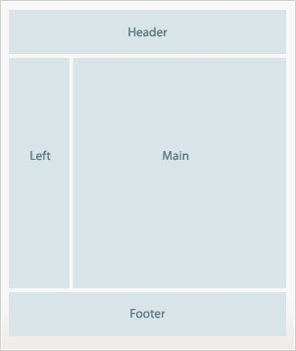

Figure 8: Magento container

To be capable of showing contents, containers must be filled with blocks. Blocks generating HTML codes added to the parent's form are what users can see. They contain a connection between a logic class and a PHTML template file which can be written in both PHP and HTML. Each of them represents different features on a web page, making layout handling easy and clear.

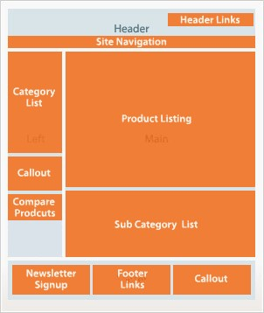

Figure 9: Magento block

As to this practice, since Magento already has its demo themes, the job is to rearrange them and create new theme modules if needed along with using LESS for styling to produce a web page. Therefore, dealing with blocks and containers are indispensable. There are four main tags that are usually used:

* "*Block*" and "*Container*": to make new sections.
* "*ReferenceContainer*" and "*ReferenceBlock*": to extend, modify root containers and blocks of the framework.

The result theme is a brand new home page having its own header, footer, and content. In the content, there are two sliders for best-selling products and new products created by Slick.js, a powerful jQuery plugin for sliders that work with any HTML elements. The theme is carefully made responsive for every popular screen size from desktops to mobiles. Slick.js is also applied in some elements of responsive screens for mobiles such as the navigation bar and the footer links. Besides, there is additional styling for other Magento pages namely the registration page, the category page, and the checkout page… based on a style guide. The functions on these pages do not change a bit, only their styles are modified to match the home page theme.

#### b) Fast Order extension

Making a functional module is the main target of the internship. Fast Order is a customer-oriented utility which enables users to search and purchase a long list of products rapidly without difficulties. The business logic of the extension is implemented with Knockout.js, the architecture and some ready-built functions of Magento 2.

In this project, there is no need to build a new database because it is just a function dealing with existing products. Therefore, the design that needs to be analyzed here is the product’s database of Magento which is an EAV model. EAV stands for Entity-Attribute-Value, a data model that works with entities having auto-extending attributes:

* **Entity**: a table for Magento data objects such as products, categories…
* **Attribute**: represents data pieces that belong to an entity namely price, name, color…
* **Value**: is simply a value of an attribute. For example, values for attribute color can be red, green, black…. Along with an attribute, this is a pair to describe a fact of an entity.

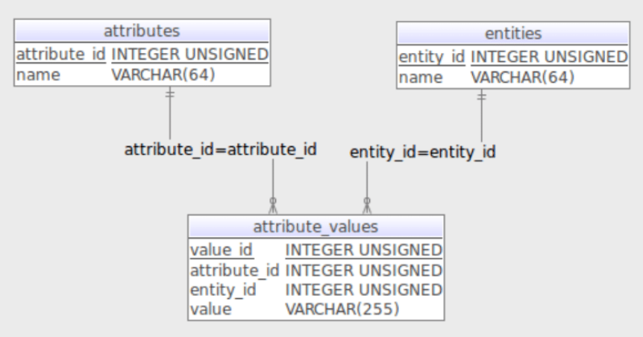

Figure 10: EAV model

According to the general EAV design structure, there are three tables: *entities*, *attributes*, and *attribute_values* (or *values*) and their relationships can be described as follows:

* **Attributes – Attribute_values:** one-to-many relationship: an attribute has many values but a value must belong to just one attribute.
* **Attribute_values – Entities:** many-to-many relationship: an entity has many values and a value can appear in many entities
* **Entities – Attributes:** many-to-many relationship: an entity has many attributes and an attribute belongs to many entities.

Apply EAV, Magento has the following database design for products:

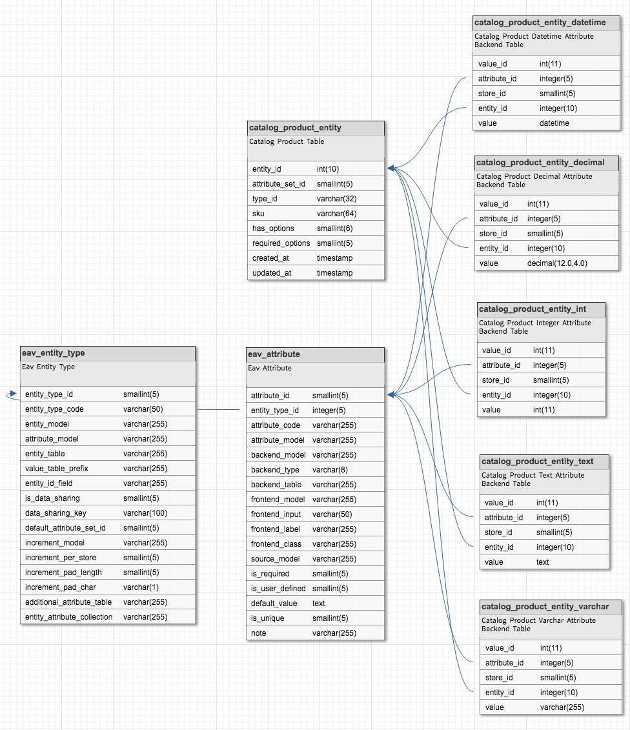

Figure 11: Magento product EAV

* *eav_attribute*: a table of attribute’s information
* *eav_entity_type*: stores information of an entity type containing the entity model, default attribute set…
* *catalog_product_entity*: determines product entity (similar to the *product* table)
* *catalog_product_entity_[data_type]*: the last five tables on the right of the design are the attribute’s value tables corresponding to the data types. They connect to the exact content of the entity’s characteristics.

Compared to the usual flat model whose attributes correspond to different columns in a same table, EAV is much more scalable. Since the model stores attribute values in separate tables, which generates a row instead of a column for each of them, developers can easily add new attributes and manage adjustment without modifying the core database structure. Additionally, the EAV model not only can omit null data to save memory space but also supports multi-nation and multi-languages management.

### 2. Architecture

#### a) System architecture

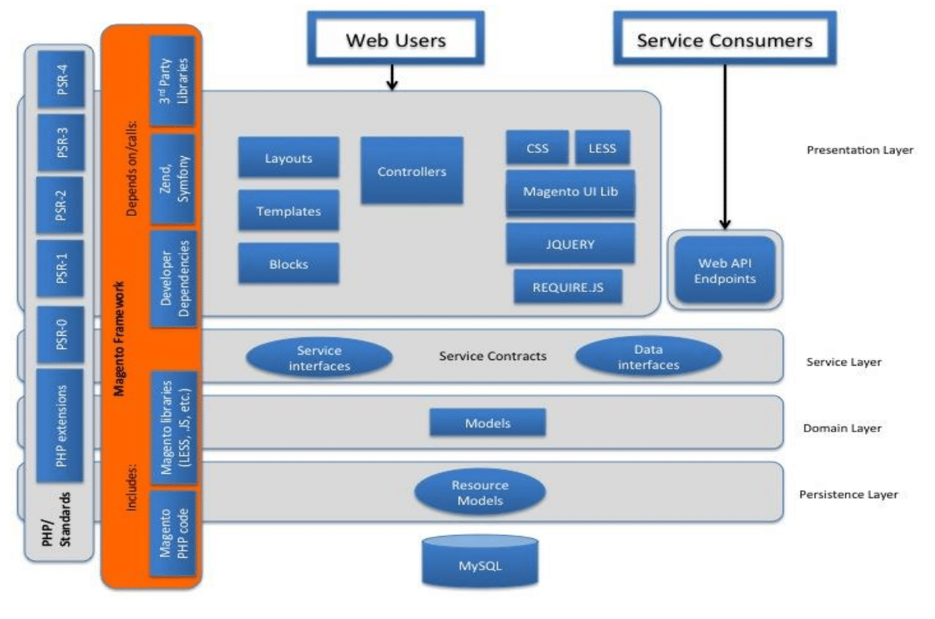

Figure 12: Magento system architecture

The system has a four-layer architecture on which classes and components of the module are scattered. First of all, all PHP classes of the four layers must be based on Magento framework and PSR (PHP standards recommendations).

**The presentation layer** is the uppermost layer. The interaction between customers and web interfaces happens here. This layer contains controllers and demonstrative elements like layouts, templates, CSS...

The second one is **the service layer** that is the communicative gate between the model and the presentation. It implements service contracts by PHP interfaces, which allows any changes of the internal business logic without destroying the system. The service layer is also the condition for other services accessing API.

**The domain layer** is in charge of business logic defining which operation should be executed on the specific data types. In Magento, retrieving data from the database is not performed directly by the model in this layer but it must refer to another class called resource model.

Resource models are located in **the persistence layer**. Additional business logic capabilities are implemented here to make CRUD requests for data extraction and modification.

In fact, this architecture clearly shows Magento’s modifications in the traditional MVC design pattern. MVC stands for Model-View-Controller which is a software design pattern for modern web applications. It is useful in dividing the program logic into specific elements:

* *VIEW*: shows the model's data to the users, represented in three elements
* *Block*: a unit that makes up a web page by associating a block class to a template
* *Layout*: contains XML files for page layout and page configuration
* *Template*: PHTML files (written in both PHP and HTML) to render content
* *CONTROLLER*: serves as an intermediary between the model and the view. It listens to events triggered by the view via HTTP requests and calls to appropriate methods on the model. A controller in Magento has several actions for different methods, each of which provides unique functions when communicating.
* *MODEL*: represents the application data structure and contains methods that help users to interact with the information in the database. It is expressed by the domain layer and the persistence layer in Magento (model and resource model). In these two layers, Magento applies a programming technique called ORM (Object Relational Mapping) that maps records in the database to objects in the current programming language. ORM allows using an object-oriented paradigm when communicating with the database, which helps developers work directly with objects in the used language.
* *Resource model*: interacts with the database and performs CRUD operations. This layer uses a class called *collection* to list all records from a table for the model.
* *Model*: manages records and defines generic data objects.

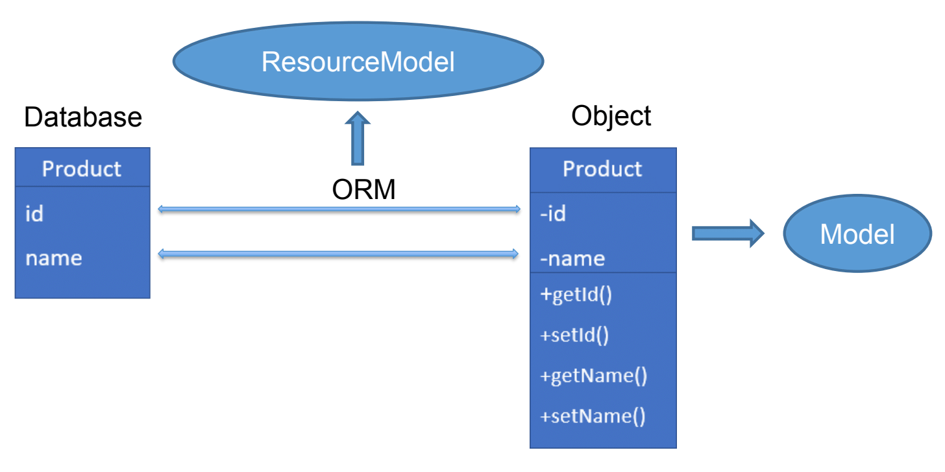

Figure 13: ORM programming technique

#### b) Module architecture

The Fast Order module works with Knockout.js a lot, so it makes use of advantages of the MVVM design pattern. MVVM is short for Model-View-ViewModel where the *Model* is the application’s stored data, the *View* represents UI of that data and the *ViewModel* is the connection between the two with the mission to detect changes of the model data and then update appropriate elements in the view (the *ViewModel* is somehow similar to the *Controller* in the MVC design pattern). More specifically, the *ViewModel* is the JavaScript representation of the model with special variables and functions to deal with the data. Below is the graph of the design pattern:

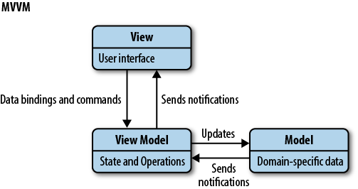

Figure 14: MVVM design pattern

### 3. Implementation

**CREATE A NEW MODULE**

First and foremost, developers must register a new module through *“registration.php”* and *“module.xml”* files. Then, a route file for front name in the URL must also be created to access to the module. Here, the front name is set as *"fastorderpractice"* so that when users use the module, the URL should be *"http://127.0.0.1/magento/fastorderpractice/"* where the former *"127.0.0.1/magento/"* is the default URL of Magento and the latter is the module route’s front name.

After that, a controller *“index”* with primary action *"index.php"* is built. It is responsible for initializing the page layout through page factory in Magento, which is presented by this line of code:

return $this->_pageFactory->create();

Subsequently, there must be a view to render HTML and LESS for the module by following these steps:

* Create an XML layout with the name in this form: "*frontname_controller_action*" to declare the overall structure of the page and return a template.
* Make a PHTML template file defining two things which are the component (a JS file referring to the *ViewModel* in the MVVM design pattern) and the template (a HTML file referring to the *View* in the MVVM design pattern). These two files are closely related to each other since the first one defines module's methods while the second one provokes those methods.

**SEARCH FUNCTION**

From the input area of the template file, key words are sent to the controller’s action through the *ViewModel*. In this case, the action’s name is *“search”* defined by the URL *"http://127.0.0.1/magento/fastorderpractice/index/search"* (where *“index”* is the controller and *“search”* is its action) and stored in variable *“serviceUrl”*:



Figure 15: "search" action's URL

Assume that a user enters “*bag*” to the search bar, the array is captured in *“search_keyword”* variable and sent to the controller’s action by POST method using *“storage.post()”* function of Knockout.js in this form:

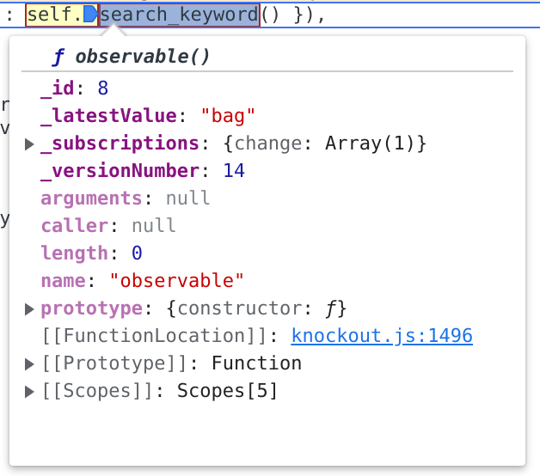

Figure 16: Search keyword’s data sent

In the controller, when the keyword is received, it will be filtered through the product list to get the ones whose name or SKU code is similar to it. To do that, the controller’s action must access the *product’s collection class* (its mission is to get all data records in the table) in the *resource model* to get Magento's data (this process is based on the ORM technique). When having the product records, developers should use *addAttributeToSelect()* function to select their attributes by accessing the product’s EAV model (including *eav_attribute, eav_entity_type, catalog_product_entity,* and *catalog_product_entity_[data_type]* tables) and *addAttributeToFilter()* function to filter products based on the keywords, which all are ready-built functions of the *product’s collection class* of Magento. When having satisfied products, the controller returns their data to the *ViewModel* in the form of an array:

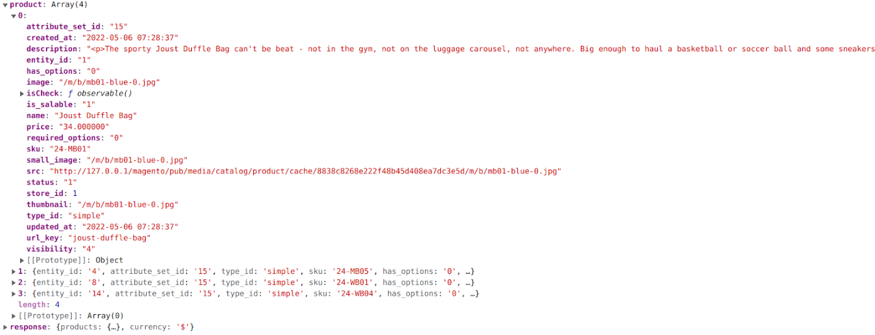

Figure 17: Product’s data received

In this example, the returned array *“product”* has four values, each of which stands for a product having attributes like *“entity_id”, “image”, “name”…*

Based on the returned data and customizing LESS, the template shows products to the users so that they can choose the desired ones to save to a list, which is implemented using some basic Knockout.js functions.

**MANAGE-PRODUCT-LIST FUNCTION**

When having the product list, functions to update quantities and price are also implemented using simple Knockout.js. In the end, when the list is determined and submitted, data about product IDs and quantities is extracted and again sent to the controller via the *ViewModel*. This time, the receiving controller’s action is different: *“add”*. Its whole URL *"http://127.0.0.1/magento/fastorderpractice/index/add"* is still stored in *“serviceUrl”* variable.



Figure 18: "add" action's URL

Similar to the search function, the submission is executed using the POST method. The information after extraction is covered in *“cartProducts”* array and sent to *“add”* controller action as follows:

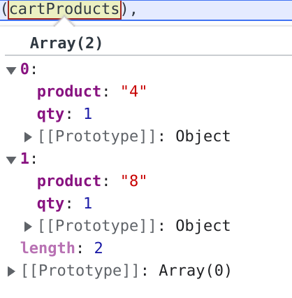

Figure 19: Product list's data sent

In the picture above, the *“cartProducts”* array has two values representing two products with two elements *“product”* and *“qty”* imply their IDs and quantities.

The controller action firstly tries to get the correct products from the database based on those IDs, then it uses two available functions *addProduct()* and *save()* in the Magento cart model to push them to the cart. If the controller succeeds in adding, it will inform the *ViewModel* to clear the search result and the product list. Otherwise, there will be an alert on the interface.

# RESULT AND DISCUSSIONS

### 1. Result

After three months of hard work, this project has achieved some significant results. Starting with the home page theme, although it does not really relate to the module, it helps me a lot in getting used to Magento and understanding the basic workflow, the folder structure and special characteristics of the framework. The home page is carefully made and styled for all screen sizes. Below is a snapshot of my theme and its detail is shown more in the appendix:

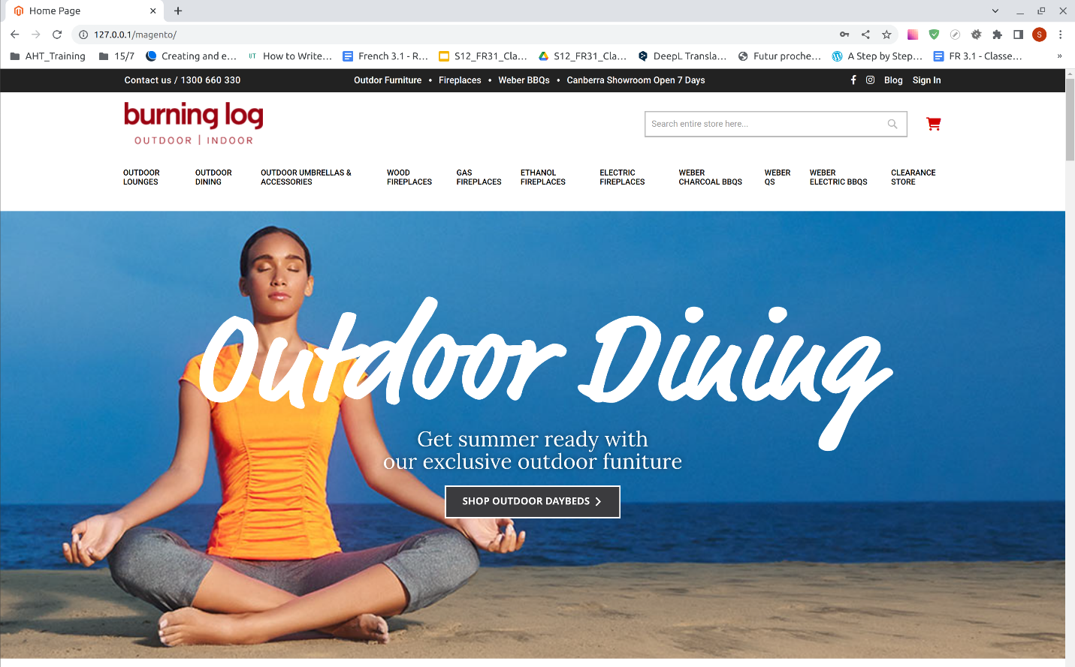

Figure 20: Magento theme customization

Regarding the Fast Order module, it is like an Magento extension that can improve the performance of the store. I have succeeded in implementing all the required functions. Instead of Magento’s traditional ordering, customers can now benefit from this project to do search and make order lists rapidly. Utilizing fast update technique, users can also make changes to those lists and keep track of prices (including the total price, the detailed price of each product, and the subtotal price of a product in the list) without unpleasant waiting time. The project is almost perfect, the only drawback is that it can only work with simple products (physical ones having single SKU code) and it fails to deal with more complex items namely grouped or configurable products. Here is another general snapshot of the module (the main objective of the project), the detail can be seen in the appendix:

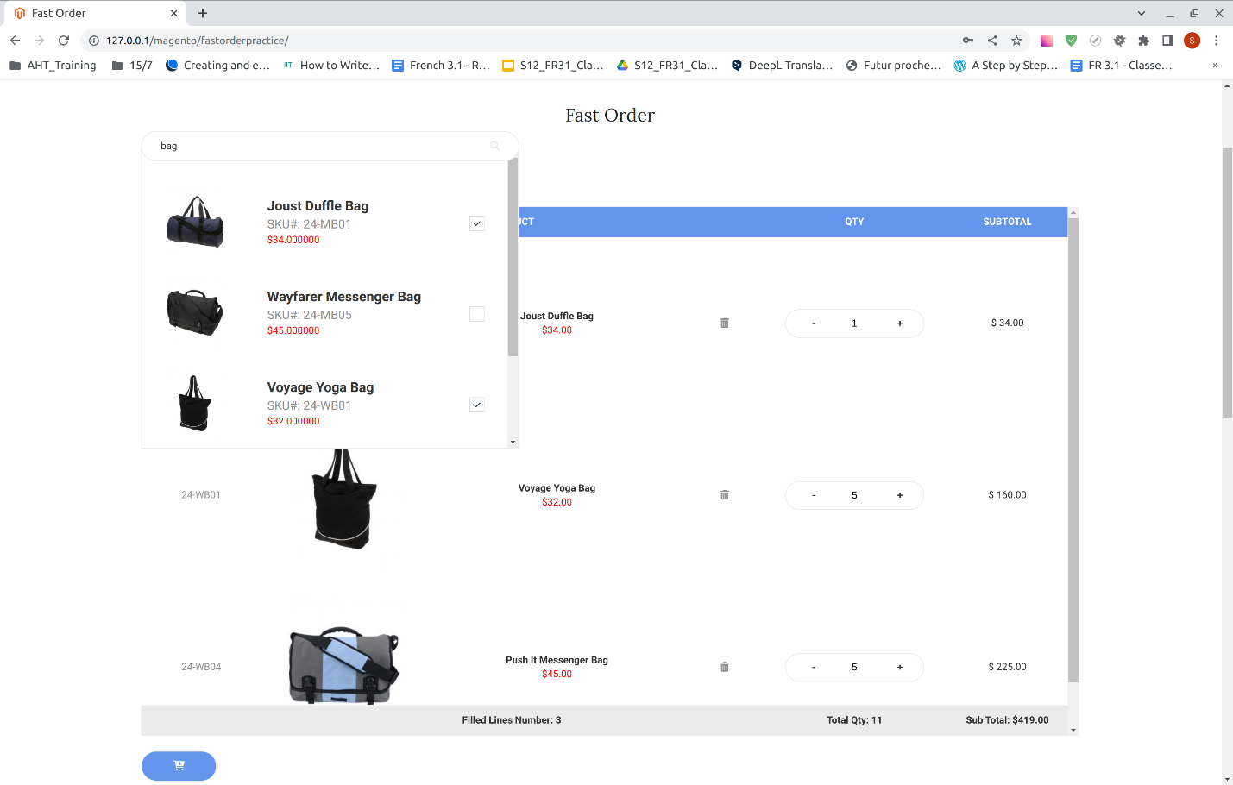

Figure 21: Fast Order module

### 2. Discussion

Magento is a complex framework due to its dense design patterns and programming techniques. If considering only the functions of this project, it may seem simple and minor. However, to finish the module without being familiar with Magento is impossible. Actually, according to the timeline, two thirds of the internship is spent to understand just the most fundamental parts of the platform. Therefore, as a whole, this project is not straightforward at all. Even when I was able to implement all use cases, there are still some bugs that I could not manage to fix including failure to deal with complex products and to show correct price form in the search area. I did not have enough time to remove those flaws, but I was suggested to improve the controller for the former and to develop a new data binding for the latter in the future.

# CONCLUSION

The three months of my internship at ArrowHiTech Joint Stock Company on the subject “Research Magento E-commerce platform: Create a Fast Order Module” was a precious opportunity for me. Firstly, I received the occasion to apply knowledge from USTH, especially in the course Web application programming and Group project to the respective field. Thanks to valuable information about HTML, CSS, JS, PHP, OOP and practice from the project, I could save a lot of time revising and fixing basic bugs, particularly when working with a PHP framework like Magento. Therefore, I had more chances to study complex materials, acquire new programming techniques and improve soft skills. In fact, during my internship, I was able to join a course at AHT named Global Citizen which not only boosted my teamwork, communication and time management skills but also expanded my relationship with other members in the company to have a better perspective about the career. To sum up, this internship perfectly fulfilled my expectations and I hope it will do for the next USTH generations, too.

# REFERENCES

* [Adobe Commerce Developer Guide ] Adobe Commerce Developer Guide,

from <https://devdocs.magento.com/>

* [AHT Training] AHT - Training: Log in to the site,

from <https://edu.arrowhitech.net/my/>

* [AHT] AHT,

from <https://www.arrowhitech.com/>

* [belvg] How EAV Data Storage Works in Magento 2,

from <https://belvg.com/blog/how-eav-data-storage-works-in-magento-2.html>

* [Mozilla] What is JavaScript? - Learn web development | MDN,

from

<https://developer.mozilla.org/en-US/docs/Learn/JavaScript/First_steps/What_is_JavaScript>

* [mysql] MySQL,

from <https://www.mysql.com/>

* [php.net] PHP: Hypertext Preprocessor,

from <https://www.php.net/>

* [Team, T] Team, T. Getting started | Less.js,

from <https://lesscss.org/>

* [W3Schools] W3Schools Free Online Web Tutorials,

from <https://www.w3schools.com/>

* [Zend] Zend, Home - Zend Framework,

from <https://framework.zend.com/index.html>

# APPENDICES

**APPENDIX 1**

Practice making a theme with LESS





**APPENDIX 2**

Practice CRUD with Magento admin system

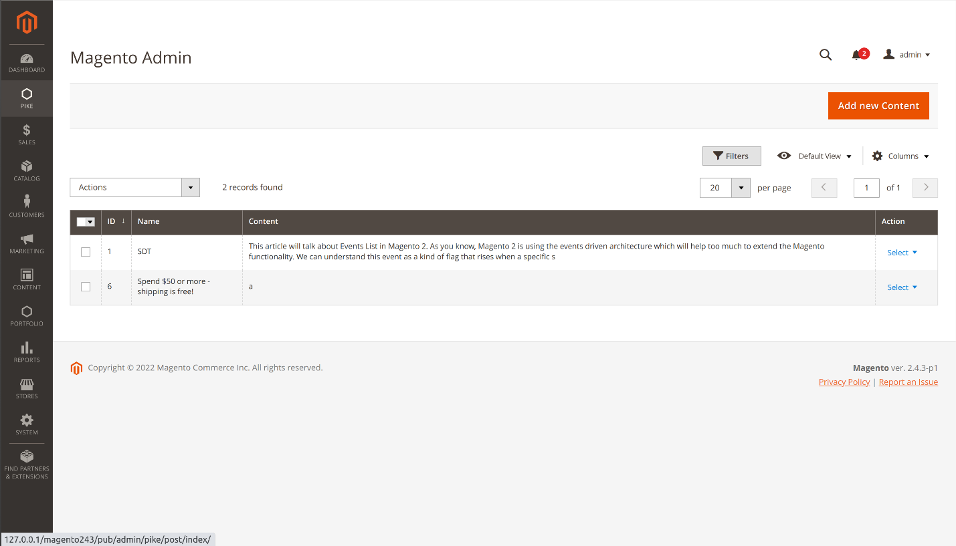

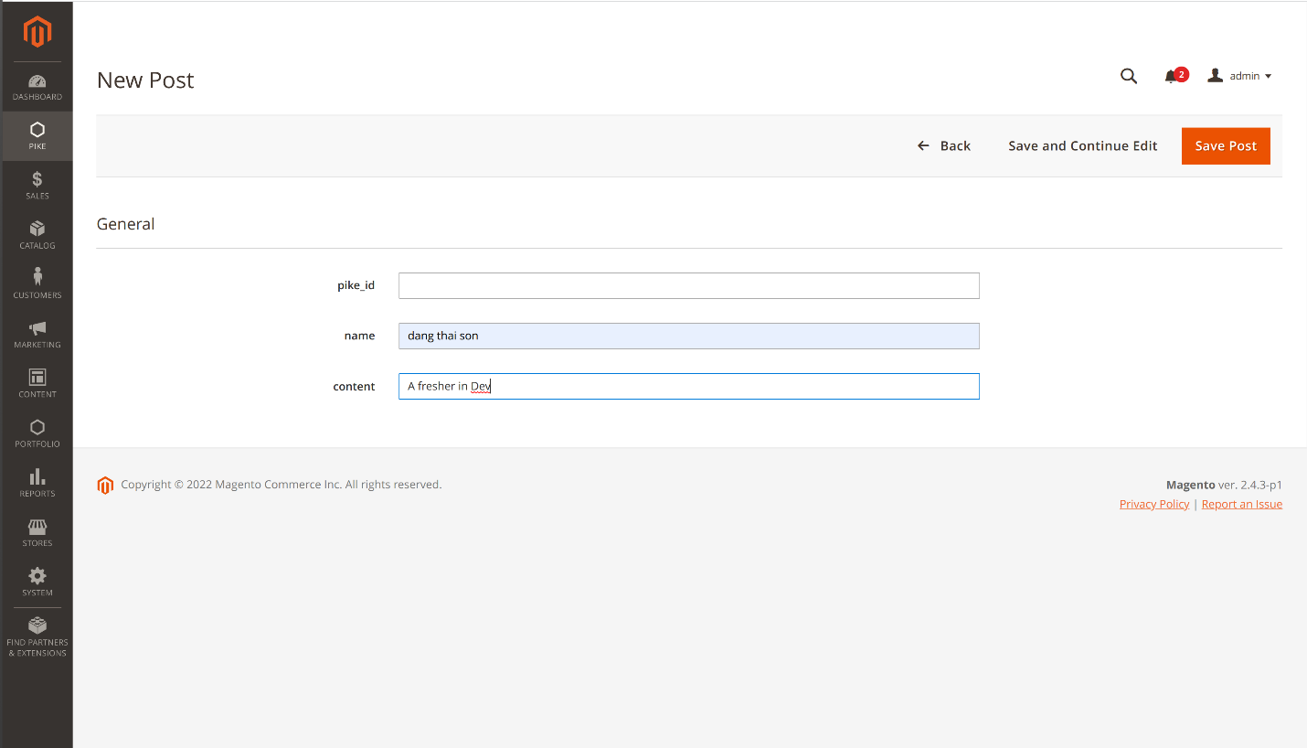

**APPENDIX 3**

Customize a Magento theme





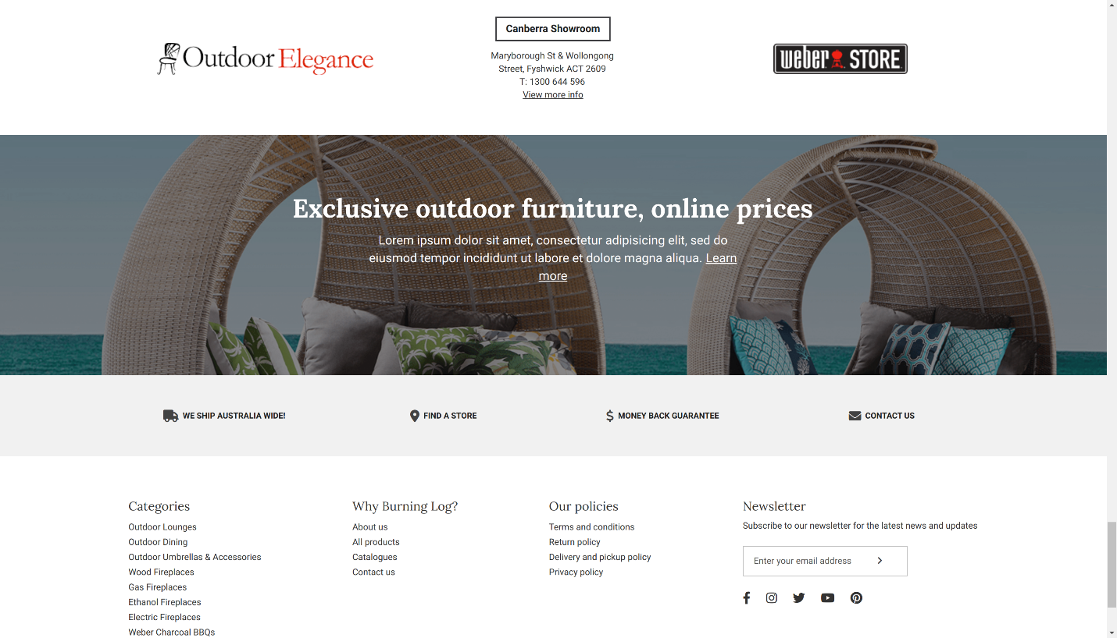

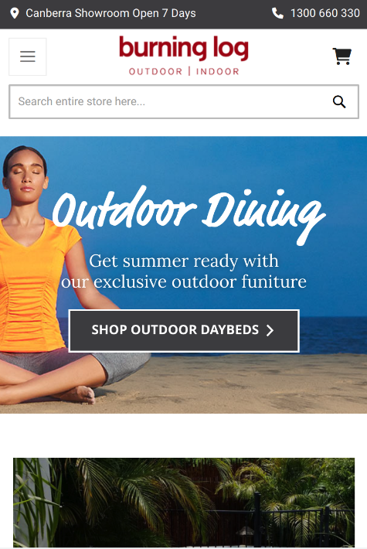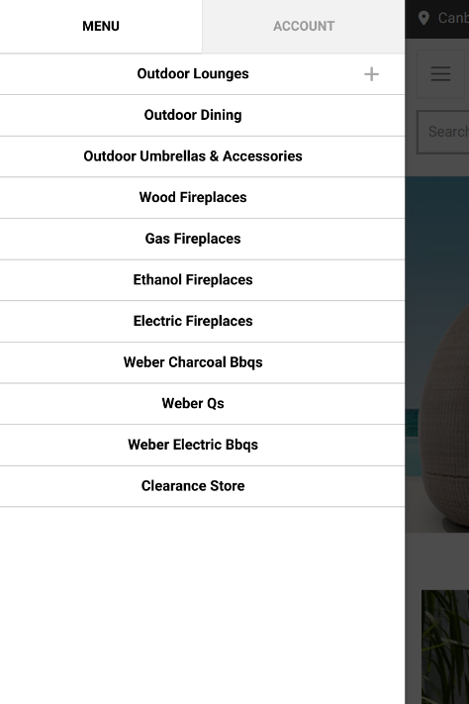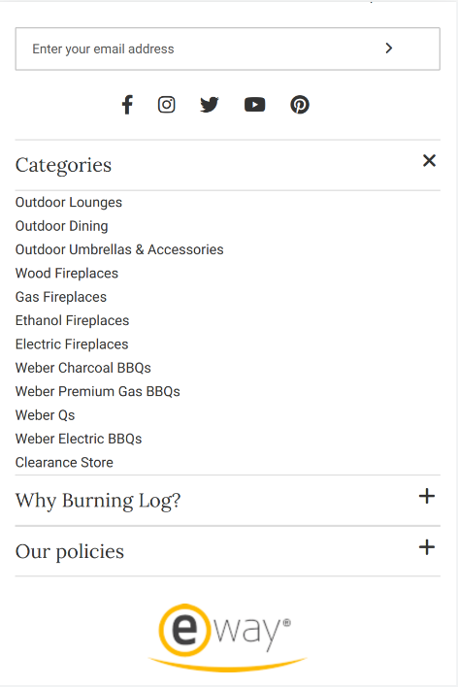

**APPENDIX 4**

Magento Fast Order module

